COSC 4P01- Software Engineering 1
Assignment 2
Due date: Wednesday, October 21, 2020, at 23:55 (11:55 pm)
Delivery method: the student needs to deliver the assignment only through Sakai.
Attention: check the Late Assignment Policy.

Name: Tennyson Demchuk Student ID: 6190532

Questions:
- To implement a Library Management System using XP, what are the key steps of the project before starting the first iteration? What are steps from the beginning of the first iteration until the end of the second iteration? What features would you consider for the first and second iterations? (3 pts)

The key steps prior to starting the first iteration are the development of user stories (high level requirements descriptions) with the customer, followed by release planning, where user stories determined to be included in the next (first) release based on time constraints and their priority level as determined by their importance to the overall project. The user stories are then transformed from high-level descriptions into a list of technical tasks that need to be completed.

The steps from the first iteration to the second are as follows:
- Iteration planning: consider features (user stories) to be implemented in the next iteration, as well as any bugs discovered in the previous iteration’s testing phase to create a list of items that need to be completed in the next iteration.
- Development: planned features and fixes are implemented in code alongside constant refactoring of exiting codebase to improve simplicity and cleanliness.
- Testing: automated tests are performed to test new functionality for correct operation as well as pre-existing functionality to ensure nothing has broken. If any test fails, then the corresponding bug will need to be fixed in the next iteration.
- Release: if all tests pass (and the customer approves of the changes), then the product in its current form is released.

In a Library Management System, some features I would consider for the first and second iterations are:
- Book inventory database – what books the Library has in its collection to offer and where they are physically stored (when available).
- Library patron accounts – store contact information and name of patrons. Each patron assigned a library ID.
- ‘Borrow’ functionality – mark books as ‘borrowed’ or ‘available’ to indicate availability. Link account of patron who has borrowed a book and keep track of how long they have had it. Automatically send notification to patrons with overdue books.
I would choose these features to be completed in the first two iterations because they are the most critical features of an effective library management system. As such, they will have the highest priority and should be implemented as quickly as possible.

- To implement a Library Management System using SCRUM process, what are the key steps before starting the first iteration? What are steps from the beginning of the first iteration until the end of the second iteration? What features would you consider for the first and second iterations? (3 pts)

They key steps prior to starting the first iteration are the initial outline planning phase where the project’s general objectives are established along with the project’s product owner (PO), and user stories are generated. Then the selection phase occurs where tasks are delegated to the product backlog in an order (priority) of the product owner’s choosing. This priority determines the approximate order in which features are developed. Finally, a sprint planning meeting takes place where a number of the topmost items from the product backlog are assigned to the sprint backlog to be completed during the upcoming iteration (sprint).

The steps from the first iteration to the second are as follows:
- Review: consider product backlog and any unfinished work from previous iteration.
- Sprint planning: select high priority items from the product backlog to be included in the upcoming sprint and add them to the sprint backlog. Expand upon these selected items and describe them in more technical detail.
- Sprint: initiate a fixed length sprint period where the development team works to complete all items on the sprint backlog. Short scrum meetings are held daily between development team and the Scrum Master to keep the team up to date on progress and any issues causing progress blocks.
- Release: if the product is in a stable state, a release can be made.

In a Library Management System, some features I would consider for the first and second iterations are:
- Book inventory database – what books the Library has in its collection to offer and where they are physically stored (when available).
- Library patron accounts – store contact information and name of patrons. Each patron assigned a library ID.
- ‘Borrow’ functionality – mark books as ‘borrowed’ or ‘available’ to indicate availability. Link account of patron who has borrowed a book and keep track of how long they have had it. Automatically send notification to patrons with overdue books.
I would choose these features to be completed in the first two iterations because they are the most critical features of an effective library management system. As such, they will have the highest priority and should be implemented as quickly as possible.
- What are the differences between XP and Scrum? Mention 4 differences (1 pts)

Four differences between XP and Scrum are:
- In XP, the customer determines the priority of tasks to completed via user stories and that priority is to be strictly followed by the development team via the features to be completed during each iteration. In Scrum however, even though the product owner assigns a priority to items on the backlog, the development team has full control over the order in which those items are worked on.
- In XP, iterations are usually relatively short (~2 weeks), whereas in Scrum an iteration is called a “sprint” and may generally be longer than an XP iteration (~2-4 weeks).
- Unlike XP, Scrum focuses on the management of iterative development rather than the management and mandating of specific agile practices such as test-first development, refactoring, simple design, small releases, and pair-programming.
- XP is somewhat flexible with regards to the tasks to be completed during a given iteration as the customer is always part of the team, however Scrum is more rigid, with the development team (sans Scrum Master) being isolated from the product owner during a sprint and being left to work on only the agreed upon list of items in the backlog until the sprint’s completion.

- What are the principal stages of the requirements engineering process? What are user requirements and system requirements? (3 pts)

The principal stages of the requirements engineering process are:
- requirements elicitation and analysis – software engineers collaborate with system stakeholders to identify the application domain, the required system services, and any operational constraints.
- requirements specification – a detailed formal system requirements document is created from the information uncovered from the elicitation and analysis process.
- requirements validation – the process of demonstrating that the requirements as outlined in the requirements document accurately define the system according to the customer.
- requirements management – the process of handling changing system requirements throughout requirements engineering and system development.
User requirements are descriptions of the services the system provides and its operational constraints through natural language statements and diagrams. User requirements are written for customers.

System requirements are detailed descriptions of the system’s functions, services and operational constraints laid out in a structured document. This document describes requirements in more technical detail than user requirements and can serve as part of a contract between the client and contractor.

- What is the difference between functional and non-functional requirements? Also mention 2 examples of each for a Library Management System (2 pts)

Functional requirements describe the functionality of a system or the specific services it should provide, or in a more general sense, it’s behaviour. Whereas, non-functional requirements describe the constraints on the system’s services and functions, such as required performance targets, and constraints on the development process (required IDE, language, standards to adhere to, etc…).

For a library management system, functional requirements may be:
- Books cannot be borrowed if they are already borrowed (checked out) – reject request to borrow or invalidate option.
- If a book is searched for and found to be not in the system inventory, provide the necessary details for the librarian to order it.

And non-functional requirements may be:
- System must be developed for and thus operate correctly on Windows XP.
- Book search cannot take more than half of a second.

- What is requirements validations and list three requirements validation techniques? (2 pts)

Requirements validation is the process of demonstrating and ensuring that the requirements accurately define the system according to the customer’s vision. Three requirements validation techniques are:
- Requirements reviews – frequently held, formal or informal manual reviews of the requirements definition during the requirements engineering process by developers and stakeholders.
- Prototyping – using a prototype executable to test the accuracy of the current requirements definition.
- Test-case generation – using automated tests to check the requirements definition.

- What is described in a context model? How are activity diagrams used in describing the context of use of a system?(1 pts)

A context model describes the environment in which a system is being developed by showing the other systems that will share that environment without describing the role of that system. Activity diagrams are used to describe the context of a system’s use by defining business process models for that system.

- What is described in a use-case diagram? Show an example of a use-case diagram in a Library Management System (with one actor and 3 use-cases). (2 pts)

A use-case diagram describes the relationships and interactions between system use cases and different actors within the system.

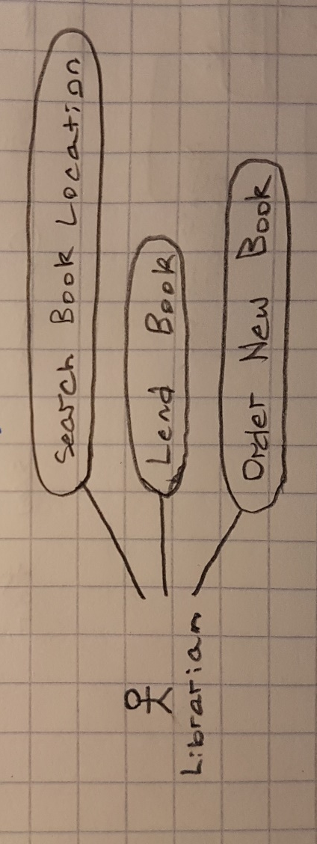

- Develop a sequence diagram showing the interactions involved when a student registers for a course in a university. Courses may have limited enrollment, so the registration process must include checks that places are available. Assume that the student accesses an electronic course catalog to find out about available courses. (2 pts)

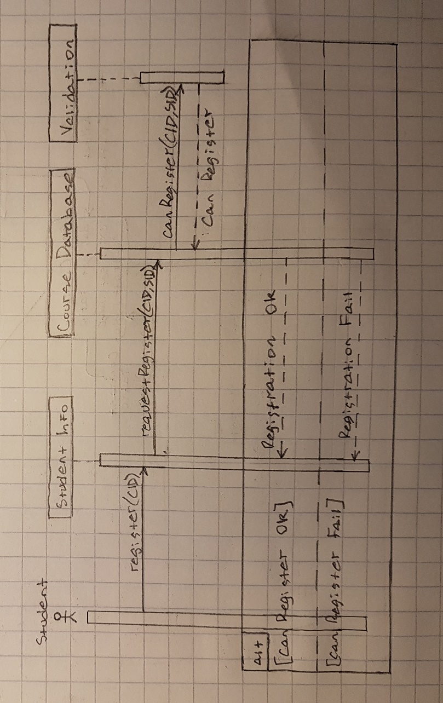

- Draw a state diagram of the control software for the control software for a digital camera (1 pts)

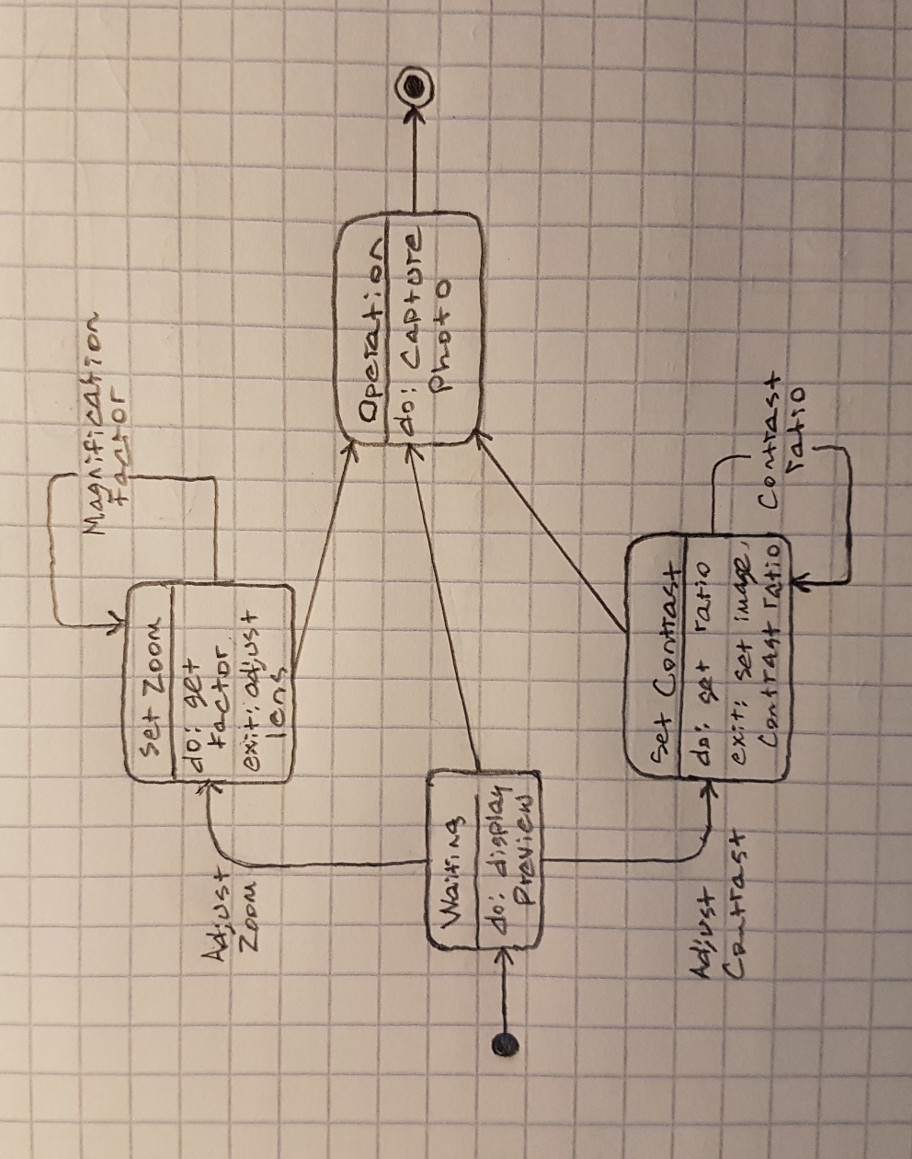

Marking Scheme:
Marks will be awarded for completeness and demonstration of understanding of the material. It is important that you fully show your knowledge when providing solutions in a concise manner. Quality and conciseness of solutions are considered when awarding marks. Lack of clarity may lead you to loose marks, so keep it simple and clear.
Submission:
The submission is expected to contain a sole word processed document. The document can be in either DOC or PDF format; it should be single column, at least single spaced, and at least in font 11. It is strongly recommended to use the assignment questions to facilitate marking: answer the questions just below them for easier future reference.
Late Assignment Policy:
A penalty of 25% will be applied on late assignments. Late assignments are accepted until the Late Assignment Date, three days after the Assignment Due Date. No excuses are accepted for missing deadlines. However, deadline extensions may be granted under extenuating circumstances, such as medical or physical conditions; please note that granting the extension is under the instructor’s discretion. However, deadline extensions may be granted under extenuating circumstances, such as medical or physical conditions; please note that granting the extension is under the instructor’s discretion.
Plagiarism:
Students are expected to respect academic integrity and deliver evaluation materials that are only produced by themselves. Any copy of content, text or code, from other students, books, web, or any other source is not tolerated. If there is any indication that an activity contains any part copied from any source, a case will be open and brought to a plagiarism committee’s attention. In case plagiarism is determined, the activity will be cancelled, and the author(s) will be subject to the university regulations. For further information on this sensitive subject, please refer to the document below: https://brocku.ca/node/10909

